# MISM MRM SOW

MISM MRM SOW 1

Project Name 2

Project Description 2

Overview 2

Problem/Opportunity statement 4

Primary user stories 5

Deliverables 5

MRM Meta-model 7

Initial reference model 10

Work products 10

*Business Model Report 10

*Program Profile Report 10

*Service Profile Report 10

SIAM Diagram 10

Hierarchy Diagrams 10

Relationship Matrices 10

MRMv2.1 Work Products Already Supported by SA 10

Additional PSRM Work Products 11

Supporting Tools 11

Lotus Quickr 14

Rational System Architect/XT 14

Optional: Rational Focal Point 14

Optional: Rational Insight, Rational Publishing Engine, Cognos 14

Optional: Rational Asset Manager 14

Optional: Rational Team Concert 14

Deployment Platform 15

System Architect Enterprise Encyclopedia 15

Optional: RAM Repository 15

Optional: RTC Repository 15

Quickr Site 15

Work Breakdown Structure 15

Resources 16

Total Cost Estimate 17

Timeline 17

Cost Recovery 17

## Project Name

Municipal Information System Association Municipal Reference Model v2.1 – MISA MRMv2.1

## Project Description

This section provides a brief description of the MRM project. Further details can be found in the MRMV2 Functional and Technical Requirements document.

### Overview

The Municipal Reference Model (MRM) is a framework or model of standard business components (i.e. Program, Service, Process, etc.) as they relate to a municipality or local government. In addition, these business components are interrelated with each other. For example a Program can be associated with one or more Services, and a Service may have one or more Processes associated with it

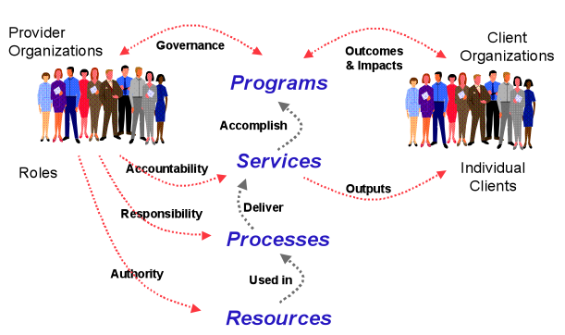

The MRM is intended to capture principles, best practices and patterns representing a reusable municipal business architecture. It can be used by municipalities to help in transitioning their organizations to better address changing constituent needs. A municipality would access the MRM and instantiate it for their particular situation. Instantiation consists of using element of the MRM to assist in municipal strategic planning, and to provide guidance for solution deployment and assessment.

The concept behind Version 2 of the Municipal Reference Model is that a municipality can draw upon one or more different types of repositories to create their own version of the repository representing their municipality (Customized “My Municipality’s Model”).

MRM Version 2 Models

The different types of models (see Figure 1) include:

* MRM Meta Model: Specifies the meta-classes and relationships that define the structure and meaning of the reference model. It is based on the Public Services Reference Model (PSRM). The life-cycle of this model is controlled by MISA and will likely change infrequently.
* Municipal Reference Model (MRM): An instance of the MRM Meta Model that represents reusable building blocks for a municipal business architecture. The reference model is also under MISA control and is expected to evolve over time as experience is gained from its use by municipalities, and to respond to new municipal influencers.
* Best Practice Model: Describes the principles and best practices for using the MRM, instantiating it in specific municipal environments, and contributing to strategic planning
* Customized Model for a given Municipality: The instantiation of the MRM for a particular municipality. These models are posted back to a central site for possible subsequent reuse, and harvesting into future versions of the MRM.
* My Municipality’s Model: A customized instance of the MRM owned by a particular municipality that is under the control of that municipality.

The MRMv2.1 is an update of the MRMv2 metamodel and reference model resulting from a migration of the supporting tooling environment to Rational System Architect, and changes needed to support the required work products.

### Problem/Opportunity statement

Municipalities are facing unprecedented challenges due to aging infrastructure, reduced tax revenues, increased constituent needs resulting from the recent economic downturn, and increased regulation and a tense political environment. Actionable municipal governance requires objective answers to questions such as:

* Why does our business exist?
* How many programs and services do we provide?
* Why do we provide those services and not others?
* Who is accountable for which services?
* Are there duplicate services?
* How much do we spend to deliver those services?
* Where is there conflicting accountability? Or no accountability?
* What program outcomes are we trying to achieve? How are we doing?
* Are the services contributing to the desired program outcomes?
* What are our service outputs? Who are the clients?
* How do we measure our success at the program level? At the service level? At the process level?
* What can be improved? Where should we focus our improvement efforts?
* What are all the services that we provide to a given target group (e.g. seniors, youth, aboriginals)?

Providing methods, reference model content and tools to answer these questions represents an opportunity for to incorporate strategic planning and business architecture into Smarter Cities. Such an offering would support a move to a “whole of government” approach to municipal planning with seamless, citizen-centered services. It would support legislation, regulations and policies that are designed rather than crafted in order to provide better alignment between organizational capabilities and desired outcomes. Strategic planning based on reusable, proven reference model allows municipalities to do more with less.

What is needed to support “Government by Design” is a consistent and formal business design capability based on a common language, principles and best practices to create better decisions in response to municipal influencers. A pan-country standard municipal reference model would provide a business architecture to enable any conceivable government line-of-business to better:

* Interpret and clarify their missions, strategies, outcomes, etc.
* Accurately depict or map how they work (and how they can work together),
* Discover opportunities for business improvements,
* Support their planning and successful implementation.

The goals of the MRMv2 project are to create a tool product and accompanying services that will help municipal governments describe their viwion, goals, objectives, programs, services and performance metrics:

* *… in a standard way*
* *… using precise definitions and concepts accepted and adopted by all governments in Canada*
* *… with tools and templates to help you create the descriptions of the municipality*
* *… with user guides and training material to help create and use these descriptions for a range of municipal purposes*
* *… with a repository where these descriptions can be saved*
* *… repository pre-populated with a generic set of service descriptions that may be provided to any municipality in Canada*
* *… repository pre-populated with specific descriptions (models) created by other municipalities*
* *… with tools that allow for the analysis and comparison of such descriptions*
* *… and with a collaboration space that allows ideas to be shared on how these tools are being used in participating municipalities*

### Primary user stories

The primary user stories for this initial phase of the MRMv2 project are described in the document MRM V2 Release 1 Business Use Cases Operations Features and Specifications v19.doc. These use cases are also described in the [MRMv2.1 Plan](https://jazzop05.rtp.raleigh.ibm.com:9943/jazz/web/projects/Municipal%20Reference%20Model#action=com.ibm.team.apt.viewPlan&page=viewModel&id=_F8wvsMBtEd-3r_Y7vI90mw).

## Deliverables

This section defines the specific deliverables of the MRMv2.1 SOW. These deliverables are defined in the MRMv2 Functional and Technical Requirements document, Appendix B – MRM End User Tool Descriptions, and have been updated based on alignment with PSRM and detailed discussions with MISA.

The deliverables as described in Appendix B:

1. A meta-model of Municipal Reference Model components, such as a “Program”, along with the attributes of a business component, such as a “Program Social Need” and the relationships among and between MRM components (MRM Meta-Model).
2. Functionality that will enable a Municipality to create a custom version of the MRM Meta-Model representing their particular business domain and comprised of, at a minimum, a set of Programs and Services (Customized Municipal Model).
3. Data repository that contains a stock set of Programs and Services (MRM Reference Model), municipal best practices (Best Practice Models) and customized versions of the MRM material for selected municipalities (Customized Municipal Models) that can be referenced, and where relevant, copied into a custom version of the meta-model.
4. Functionality that will enable a Municipality to produce various stock and custom reports from the customized version of their MRM components, and/or from the software repository of stock, best practice and customized models.
5. Functionality that will enable a Municipality to upload / download information to/from standard office tools (e.g. Microsoft Word, Excel, PowerPoint and Visio).
6. Functionality that will ensure the timely back-up and recovery of the software tool in the event of an accidental / intentional failure.
7. Functionality that will restrict or grant access to functionality provided in the Software Tool depending on the role within a municipality (e.g. administrator) and the role played within MISA / ASIM Canada (e.g. content manager). Various roles that need to be recognized include:

MISA / ASIM Canada Host / Custodian Roles:

* + Software Administrator – responsible for overseeing the changes approved by MISA / ASIM Canada to the MRM Software Tool;
  + Content Manager – responsible for overseeing the changes approved by MISA / ASIM Canada to the MRM Meta-Model components;

Subscriber Municipality Roles:

* + Administrator – responsible for correcting any version control issues, for granting access to the repository, and for providing technical support;
  + Analyst / Architect – responsible for creating, deleting, modifying and copying MRM Customized Municipal Model components;
  + Approver – responsible for reviewing and approving the Customized Municipal Model components developed by the Analysts / Architects;
  + End User – responsible for using (read access only) but not modifying the Customized Municipal Model components.

The MRM Data Repository will consider a number of steps in the process towards accepting repository entries, including:

1. Research Step – to identify candidate material to be added to the repository.
2. Approval Step – to review and approve candidate material to be added to the repository.
3. Adaptation Step – to adjust, modify, and/or add material to the source material to comply with the MRM tool standard.
4. Entry Step – to add the modified source material into the MRM tool.
5. Test Step – to ensure that the repository information was loaded correctly.

Software User Guides will consist of a number of components including:

1. User Guide for MISA / ASIM Canada Custodian – a guide that would explain how to add, delete and modify meta-model components (i.e. program, service, new component, renamed component, etc.), as well as how to add, delete and modify stock programs and services, best practice models, instances of other municipal customizations, and how to add, delete and modify stock and custom reports. This user guide would also provide a guide on how to maintain the software tool, including the addition of privileges to new municipalities who subscribe to the MRM V2 Tool. Note that this custodian user guide would not be widely circulated. In addition, the guide should include a meta-model of the objects and their relationships, such as conceptual data model and/or semantic model.
2. User Guide for Municipal Custodian – a guide that would explain how to set up a new municipal customization for a municipality and enable privileges to selected users in the municipality’s business community.
3. User Guide for Municipal Business User – a guide that would explain how to add, delete and modify business components for a specific municipality’s customized model, and how to produce stock and customized reports from the MRM V2 Tool.
4. On-Line User Guide for Software Users – a guide that would explain how to navigate around the software tool, and how to use the software tool for the various MRM applications.

Details are provided in the functional and technical requirements document.

### MRM Meta-model

The MRM meta-model specifies the meta-classes and relationships that define the structure and meaning of the reference model. The meta-model is defined in a Rational System Architect extensibility file (called USRPROPS.TXT) and is informally described by the following UML model.

**MRM Essentials**

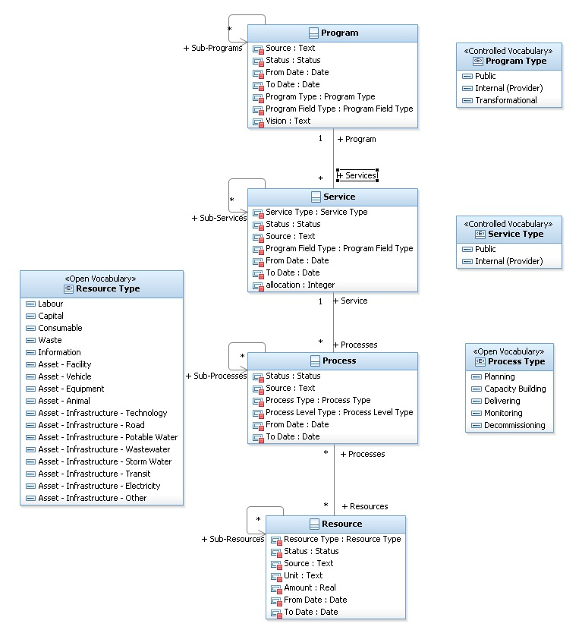

**The MRM Services Model**

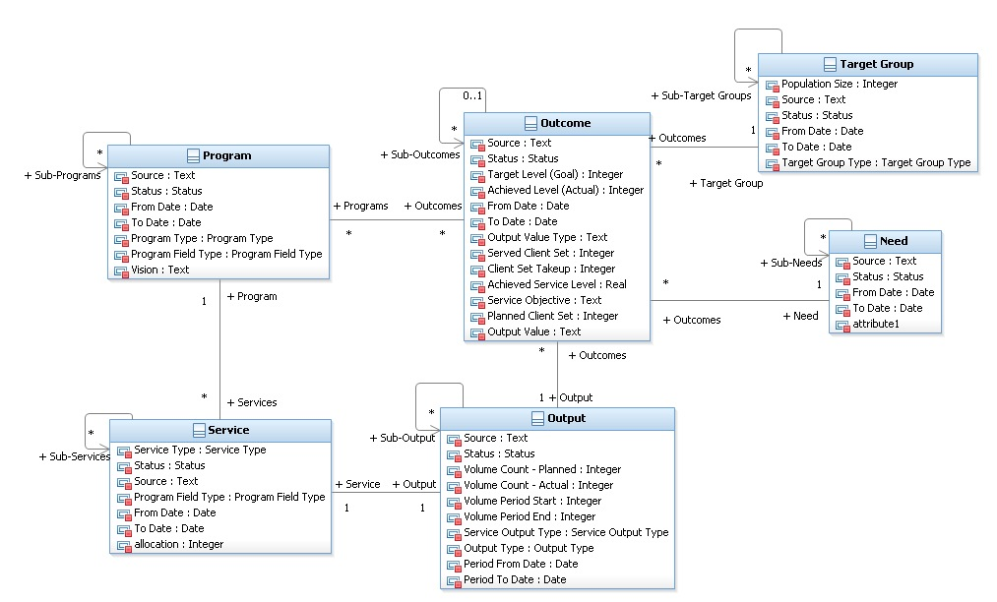

**The MRM Organizational Model**

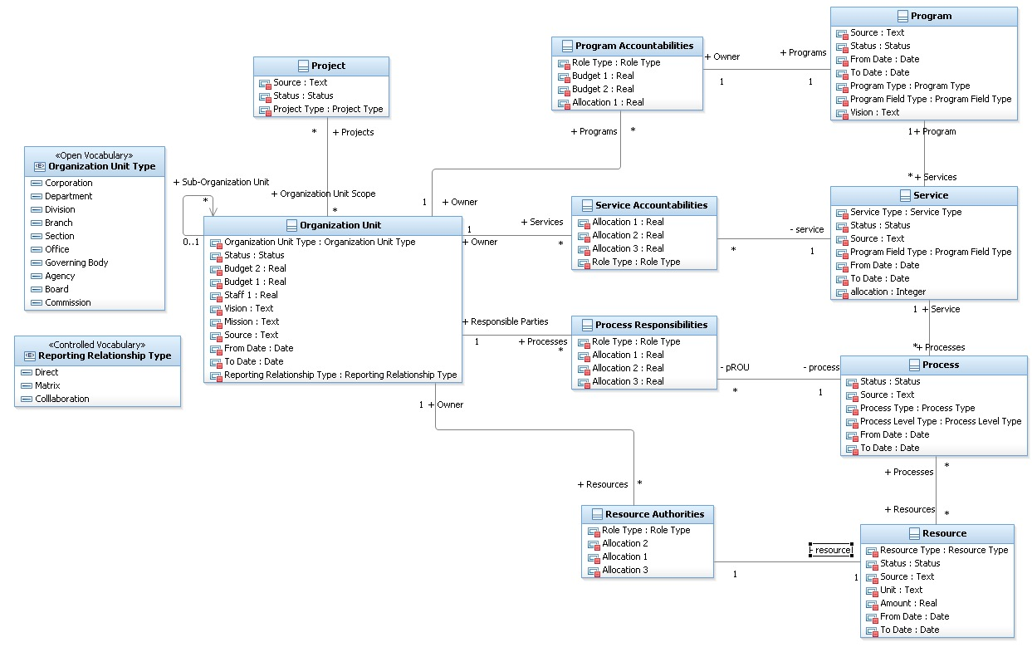

The MRMv2.1 meta-model contains minor updates of the MRMv2 meta-model reflecting modeling best practices, tooling requirements, and changes necessary to support the MRM work products.

### Initial reference model

The initial MRM reference model was derived by extracting the information out of the MRMv2 reference model implementation in Rational RequisitePro, and importing into Rational System Architect. This reference information has been extracted from a number of documents and spreadsheets through various knowledge engineering engagements in order to formalize the content in the MRMv2 meta-model. The content is essentially identical in MRMv2.1, only the structure of the meta-model was changed in order to support the tooling and work product implementations.

### Work products

Work products are used to create, validate, communicate, reason about, and act upon information in the reference and my municipal models. The following sections describe the work products that will be developed in this project.

* Indicates the work product was supported in the MRMv2 tooling platform

#### *Business Model Report

A report with selectable scope and depth to summarize the Organization Unit, Program, Service, Process, Resource model elements.

#### *Program Profile Report

A "short form" is simply the Introductory tab for the Program definition. The "longer form" includes the rest of the tabs that cover all the Program properties. The report is provides publishable summary information.

#### *Service Profile Report

A "short form" is simply the Introductory tab for the Service definition. The "longer form" includes the rest of the tabs that cover all the Service properties. The report is provides publishable summary information.

#### SIAM Diagram

Displays the "accountability chain" from organization unit through services to the assessing target group.

#### Hierarchy Diagrams

Hierarchy diagrams for all meta-classes that have hierarchies (Organization Unit, Program, Service, Process, Need, Target Group, Outcome Output Resource)

#### Relationship Matrices

Create a matrix for each relationship in the meta-model to support viewing, navigating and editing all relationships.

#### MRMv2.1 Work Products Already Supported by SA

There are a number of MRMv2 work products that are already supported by various features of Rational System Architect. These features will be used as-is.

* Data gathering templates are supported by SA definition dialogs
* Relationships (except those that have properties and are implemented as relationship definitions) are supported by matrices as well as select diagrams and the definition dialogs
* Organization Chart
* Business Process Model
* Business Process Hierarchy diagram (for PSRM Business Function Model)

#### Additional PSRM Work Products

There are a number of Metaclasses and Work Products in PSRM that are also already in Rational System Architect and could be directly reused by MRM if desired. These work products are not currently part of the MRM tooling requirements as they may be beyond the scope of what is needed by the pilot municipal engagements. However, future revisions of the MRM tooling supporting other usage scenarios and requirements may leverage these existing capabilities.

* Geographic Location
* Business Goal
* Business Objective
* Business Rule
* Business Strategy
* Role
* Business Direction Diagram
* Event or BPMN Event
* IDEF0 and physical data models
* Network Concept (for PSRM Business Network)
* State Transition Diagram
* Use Case
* Business Scenario (either a business process or use case diagram)

### Supporting Tools

This section describes the supporting tools and the roles they play in fulfilling the MRM tooling requirements.

The use of the MRM follows a typical model, develop, deploy and manage lifecycle that would be typical of enterprise architecture, solution delivery and operations management engagements.

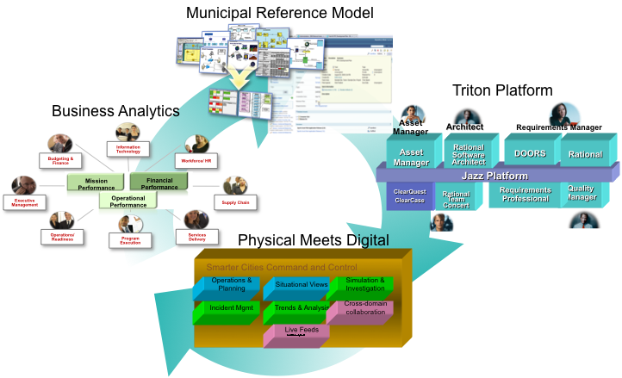

1. Municipal Reference Model

* The MRM fits into this broader Smarter Cities by providing a reusable asset for municipal strategic planning. Together the Smarter Cities tooling architecture supports:

1. The Triton Platform can accelerate time-to-value for municipal IT solutions

* **What it is:** “Triton” is a SWG asset from IBM providing an accelerated delivery of a SOA Foundation Infrastructure utilizing IBM Intellectual Property Assets including the Installation, Configuration and applicable implementation assets necessary to provide a fully functional SOA Foundation
* **What it does:** Enable delivery excellence in delivering a SOA infrastructure by leveraging SOA Implementation Requirements, best practices, documentation, scripts, effectively utilizing harvested implementation assets
* **Why use it:** To accelerate implementations (calendar and overall person/year effort) and lower risk, and leverage SOA best practices from across IBM globally.
* **Goal:** Delivery of SOA Infrastructure Functionality (as Working Vehicle) vs, SOA “Do it yourself Kit” (Pile of Vehicle Parts & Assembly Instructions & Project Plan & Crossed Fingers & No assurance it will meet functional requirements and be delivered on time/on budget….if ever.)

1. Physical Meets Digital supports Smarter Cities Command and Control to automate and manage public service sub-systems using a collaborative environment that enables a city’s core systems to become smarter:

* Collect, Filter and Manage the Right Kind of Data
* Integrate, Analyze and Operationalize the Data
* Optimize Citywide Systems to Achieve Desired Behavior

1. Business Analytics for Municipal Government

* Provides an effective means of analyzing operational information to enable effective management within the current global financial and economic environment to lay a foundation to build a better future
* Enables collaboration within and across governments and target communities for policy development, planning, execution and management

The tooling architecture supporting the development and use of the MRM consists of a set of integrated, role-specific tools supporting municipal strategic planning and MRM maintenance and governance.

Business User Artefacts:

* Login/Registration
* Home, News, Reference Material, Contacts, Help pages
* Discussion Forum
* MRM browse, municipal model browse/update
* Change Requests page

Business Analysts

* MRM access and municipal model access and update
* Business Model Report
* Program Profile Report
* Service Profile Report
* SIAM Diagram
* Hierarchy Diagrams
* Relationship Matrices
* Stakeholder-specific Browsers

Planner

* Project portfolio
* Strategic alignment analysis
* Risks, costs, time to value,
* Payback Period
* Project road-mapping

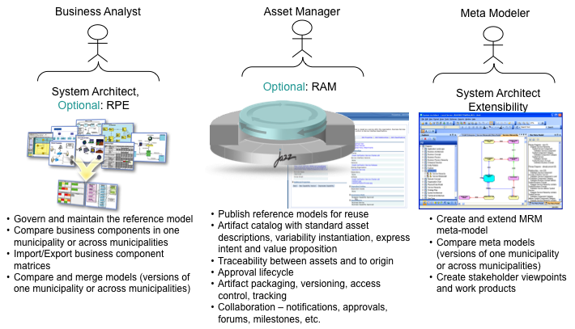

#### Lotus Quickr

Used for collaboration on the use of the MRM by individual municipalities. Provides typical collaboration facilities, blogs, Wikies, etc. Will have access to published model content and access to operational model data through System Architect/XT

Rational System Architect - used to evolve the MRM itself and its supporting metamodel, and to instantiate the MRM for use in specific municipalities.

#### Rational System Architect/XT

Provides web-based access and stakeholder views that are more appropriate for business analysts.

#### Optional: Rational Focal Point

Optional tool for municipal strategic planning and project portfolio management

#### Optional: Rational Insight, Rational Publishing Engine, Cognos

Optional tools for reporting, document production and business intelligence related to instances of the MRM

#### Optional: Rational Asset Manager

Optional tool that can be used to manage different fragments of the MRM as reusable municipal assets

#### Optional: Rational Team Concert

Optional tool that can be used for collaborative lifecycle management on the development of the MRM itself.

## Deployment Platform

#### System Architect Enterprise Encyclopedia

Provides the repository for the MRM reference model and its defining encyclopedia, and contains the information needed to support the MRM work products. Different encyclopedia instances represent different customized MRM instances obtained from municipalities, and each municipality’s My Municipality model will be a separate encyclopedia. A municipality may use Rational System Architect workspaces to manage different variants or versions of its My Municipality model.

#### Optional: RAM Repository

An optional repository for managing reusable assets. RAM could be used to manage different customized reference models, or more finely grained, separated fragments of the overall MRM.

#### Optional: RTC Repository

Rational Team Concert can be used for collaborative life-cycle management of the MRM metamodel, the MRM, and the best practices documents. RTC could provide a customized process enforcing MISA’s governance process as well as a means of managing work items contributing to the evolution of the MRM.

#### Quickr Site

Quickr us used to support the MRM Web site for collaboration on use of MRM - access to best practices, published reports, model, and access to live model though SA/XT).

Requirements from the MRMv2 functional and technical requirements document, section 3.3 MRM website:

* Ability to log in into the MRM Software Tool;
* Ability to communicate with other municipal representatives on how they use the software;
* Ability to file a bug / enhancement request on-line and to track the progress of the bug / enhancement request;
* Ability to contact various parties who may have a role in the MRM V2 software tool, web site and support services;
* Ability to post messages about the MRM V2 Software, such as upgrades, new content, new features, etc;
* Ability to store and access source documentation and reference material, such as a downloadable Practitioners Handbook; and
* Ability to link to other Web sites for reference information (i.e. GSRM, best practice sources, etc.).

## Work Breakdown Structure

Costs reflect the following summary work breakdown structure. Details are available in the [Municipal Reference Model](https://jazzop05.rtp.raleigh.ibm.com:9943/jazz/web/projects/Municipal%20Reference%20Model#action=com.ibm.team.dashboard.viewDashboard&tab=_VUcwIcDVEd-_ZY5w9aIybw) project area [work items](https://jazzop05.rtp.raleigh.ibm.com:9943/jazz/web/projects/Municipal%20Reference%20Model#action=jazz.viewPage&id=com.ibm.team.workitem).

1. Project Management
2. Program Management
3. Requirements Scoping
4. MRM Knowledge Engineering
   1. Inventory of MRM Reference Components
   2. Inventory of Best Practices Components and Models
   3. Inventory of Municipalities Customization of MRM
5. Integration
   1. Rational System Architect and Lotus Quickr
6. MRM Implementation
   1. MRM Meta-Model
   2. MRM Reference Model
   3. MRM Work Products
      1. Business Model Report
      2. Program Profile Report
      3. Service Profile Report
      4. SIAM Diagram
      5. Hierarchy Diagrams
      6. Relationship Matrices
      7. MRM Browsers
7. MRM Web Site Implementation
   1. Login/Registration page
   2. Home page
   3. News page
   4. MRM access page
   5. MRM Discussion Forum
   6. Reference material page
   7. MRM metamodel access page
   8. Change Requests page (defects and enhancements)
   9. Contacts page
   10. Help page
8. Documentation
   1. On-line help
   2. Municipal Business User Guide
   3. Municipal Custodian Guide
   4. Business Use Cases Operations Features and Specifications
   5. Workbench Design Document
9. Governance Process
10. Knowledge Transfer, Training
    1. Deployment Environment Specification
    2. Installation
    3. Configuration
    4. Backup and Recovery
    5. Best Practices Mentoring
    6. Example scenario viewlets

#### Resources

1. Program Management: Bruce Baron, Alison Oleksiak
2. Project Management: Jim Amsden
3. MRM Implementation: Three developers
4. MRM Web Site Implementation: One Developer
5. Information Development: One resource
6. Strategic Direction: Allison Oleksiak and Bob Dill

#### Total Cost Estimate

Double-click on the icon below to view the detailed WBS and time estimates.



#### Timeline

## Cost Recovery

The MRM, and its supporting Municipal Service Design Workbench can be part of an overall set of Cloud-based offerings for municipal strategic planning and to identify patterns to support downstream SaaS and/or industry software solutions.

Connecting the MRM programs, services, processes and resources to supporting solution architectures to supporting reusable BPM, SOA, etc. solution components represent a powerful customer story. That is, once a municipality has decided on its municipal business architecture change initiatives/priorities, they can get a head start on the solution design and implementation components by partnering with IBM.

The value to IBM in developing this reference model and supporting tools is through increased product and services sales driven by IBM expertise and applicable industry content. This gives IBM an edge over competitors in the Smarter Cities marketplace who do not have available reference models to give customers a head start on evolving their enterprise to meet changing client needs.

Bruce Baron discussed with his Tiger Team lead and they believe that the MRM cost recovery in the first 6-9 months would be:

* Each Phase 1 Sale: $100K deployment (SA licences, services, and possibly Focal Point POC)
* Number of sales
  + - NA: 3 States, 4-5 Cities each (or one county)
    - NE: 4-5 Cities
    - ASEAN: 4-5 Cities

This does not include the value of deployment across the multiple municipalities in Canada (dependant on what our ultimate contract outlines as required purchase) would result in the first 9 months of approximately $2.5M, which is a napkin exercise, and very conservative.